**Connecting to a Network Printer Device**

1. Click the “***Start***” menu.

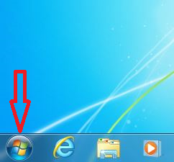

1. From the “***Start***” menu, select “***Devices and Printers***”.

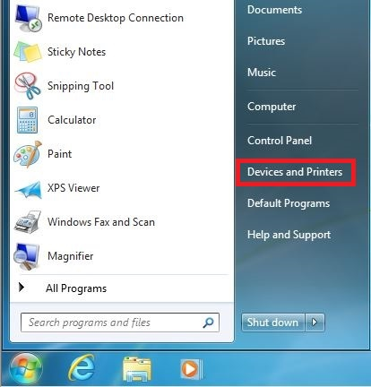

1. In the “***Devices and Printers***” window, click “***Add a printer***”.

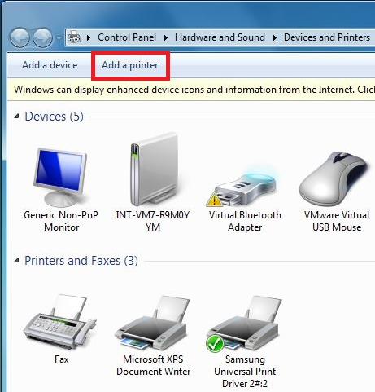

1. The “***Add a printer***” will start the “***Add Printer***” wizard for the installation. Click on “***Add a network, wireless or Bluetooth printer”*** option.

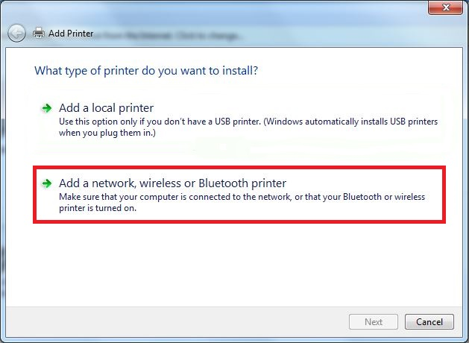

1. In the “***Select a printer***” window, click on “***The printer that I want isn’t listed***” option. Select “***Next***” to continue.

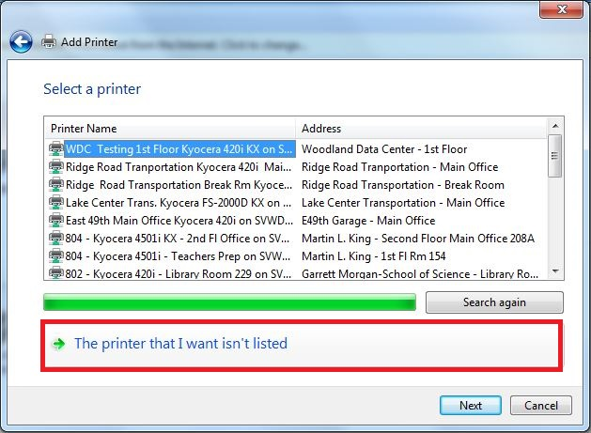

1. In the “***Add Printer***” window, select “***Find a printer in the directory, based on location or feature***” and select “***Next***” to continue.

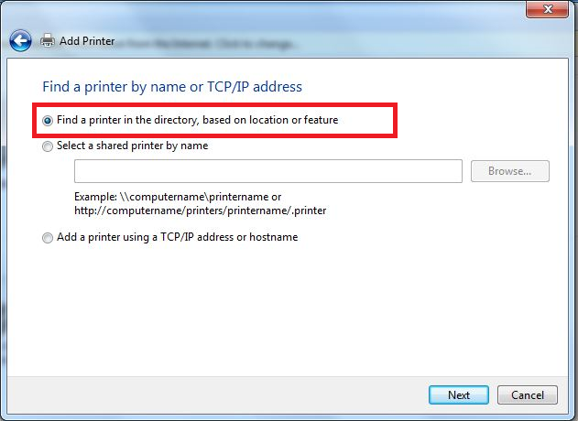

1. In the “***Find Printers***” window, type the three digit building code, e.g. “*144*” or “*001*”, into the “***Name***” field and select “***Find Now***” to list all printer devices available for you.

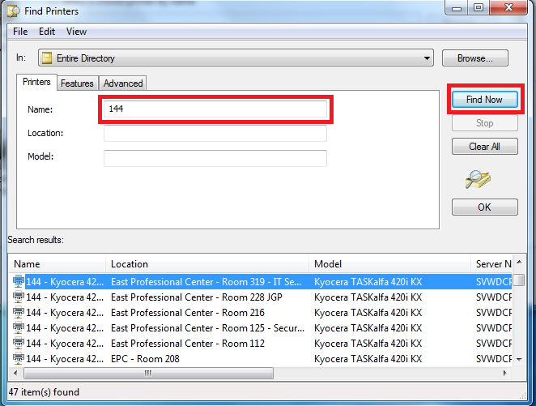

1. From the list, highlight the printer device you would like to connect to and click “***OK***” button.

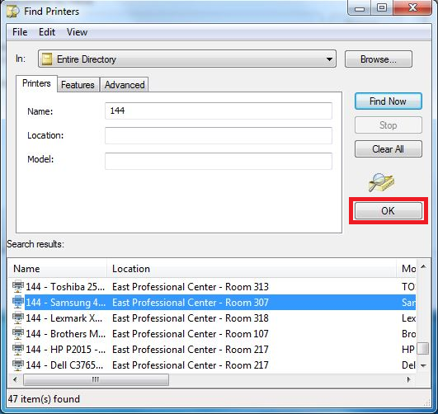

1. After clicking on “***OK***”, the system will begin establishing a connection to the printer device and, if necessary, will install the appropriate driver. After successfully connecting to the printer device, you’ll see a confirmation window stating that you’re successfully add the printer device. Click on “***Next***” to continue.

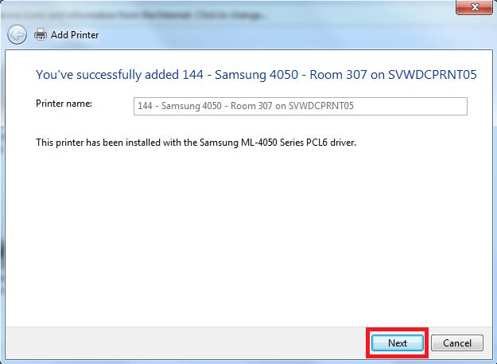

1. In the final step of the “***Add printer***” wizard
2. To make the default print device for you, check the box in front of “***Set as the default printer***”. If not, remove the check from the box
3. Click > **“Print a test page”**
4. Click > “***Finish***” to complete the wizard and the printer installation

